Third Grade News
September 15th, 2023

Reader’s Workshop:
In the first six weeks of the school year, we launch Reader’s Workshop across all grade levels at Horace Mann. It is my goal to help students create their identities as learners who care about reading and to help students develop a sense of personal agency about their reading lives, taking responsibility for becoming the kinds of readers who not only make sense of books, but also let books change their lives. At the same time, it is my job to continue to support the children in strengthening their reading behaviors-- helping them to self-select books that are “just right” in level and interest, collect and study data about their reading rates, and to challenge themselves to read with increasing stamina, fluency, and volume.
Another goal this month in reading is to help your child build a reading life. I know that the children will be creating their own 3rd grade identities, assuming roles within our community, and I want to do everything possible to encourage your child to take on the role of being a strong, powerful reader. At home, continue to make reading a part of your daily routine. Your child should be reading at least 20-30 minutes each night.
Math Workshop:
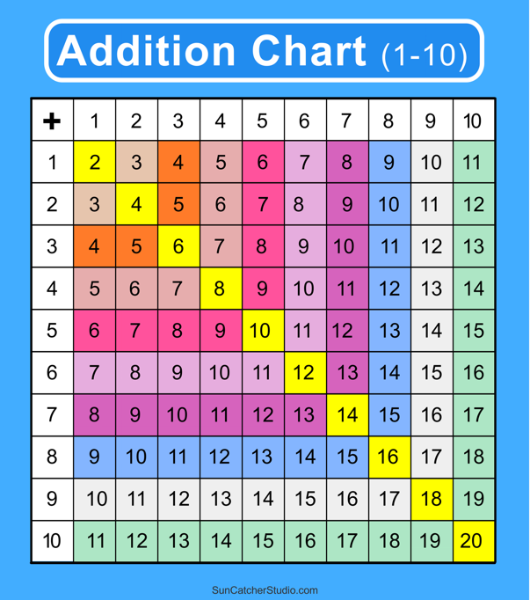
Our class spent this week working on math review routines and taking paper/pencil and online assessments. We are also learning about growth mindset and how our mathematical minds work. Next week, we plan to start our first math module!

Topics covered in this module include:

Identify Number Patterns on the Addition Table
Use Mental Math Strategies for Addition and Subtraction
Use Properties to Add
Use Mental Math to Assess Reasonableness
Round to the Nearest Ten or Hundred
Use Estimation with Sums and Differences

Writer’s Workshop:
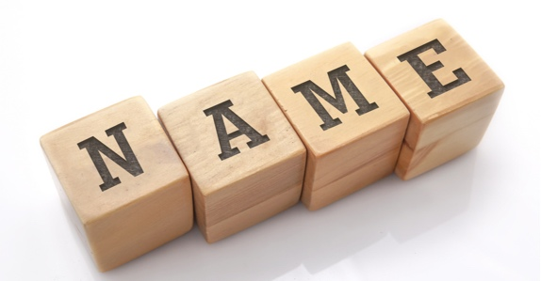
In Writer’s Workshop this week, the 3rd graders planned, drafted, edited, and published a short piece of writing about their names. The students learned the meaning of their first name, asked family members to share how their name was chosen, and reflected on what they love about their name. Using this information, the third graders planned out and wrote a paragraph all about their name. Thank you, families, for taking time to talk with your kiddos at home about how their names were chosen! Look for published writing pieces along with name art in the third-grade hallway.

Sneak Peek at Next Week:

Reader’s Workshop: Continue with setting up the rituals and routines of Reader’s Workshop, fall reading assessments

Math Workshop: Reviewing patterns, addition and subtraction, & rounding

Writer’s Workshop: Hopes and Dreams for the school year

Social-Emotional Learning: How (and when) to use our calming space

News and Announcements

- Math homework will be sent home in the Friday Folder starting September 22nd. Homework should be returned to school by the following Friday but will be accepted early if finished ahead of time. If your child needs more than a week to complete homework, please let your child’s teacher know and we can accept the work later. We are flexible!

- Apple/Smart Watches should not be used other than for telling time during the school day. They are a distraction to all children when used during lessons and work time. If your child’s watch has a “school mode” setting, please set that up at home to limit distractions while at school.

